It is the objective of T Denman and Sons Limited to satisfy the quality and delivery requirements of our customers at competitive prices. We will measure our performance in meeting customers’ requirements and work with them to continually improve the service that we provide.

To achieve this objective, the Company will maintain an effective and efficient Quality Management System based upon the requirements of ISO 9001:2015.

In particular, the Company will:

- Establish quality and business objectives that are in line with the context and strategic direction of the Company and address the risks and associated with them.
- Set measurable objectives that will help achieve customer requirements.
- Monitor and measure the effectiveness of its business processes and objectives through Management Reviews and the internal audit process.
- Proactively seek feedback from customers on how well its products and services meet their requirements and set objectives for continual improvement.
- Analyse the causes of any complaint or problem, and take appropriate action to prevent recurrence.
- Select and work closely with suppliers who enable the Company to create and deliver a reliable performance.
- Recruit employees who are customer focused and support them with appropriate training and systems to ensure their competence always meets the Company’s requirements.
- Provide a work environment that promotes the wellbeing of its employees and encourages positive teamwork.
- Encourage all employees to identify problems and make suggestions to improve all aspects of the Company’s products and services and business processes.
- Ensure that all employees are aware of the Quality Policy and are committed to the effective implementation of the Quality Management System.
- Ensure that the Company complies with all necessary regulatory and legal requirements.
The continual improvement of the Company’s Quality Management System is fundamental to the success of its business and must be supported by all employees as an integral part of their daily work.

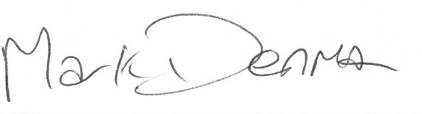
Mark Denman (Managing Director) – April 2024
To be reviewed April 2025

