T Denman and Sons Ltd is a construction company principally engaged in Repairs and Maintenance and small construction projects. The Company recognises that its business activities interact with the environment in a variety of ways. These activities have a significant impact in the key areas of:

- Raw material use
- Energy use
- Generation of waste materials
The Company recognises that it has a responsibility to help protect the environment wherever it has an opportunity to do so, be a responsible neighbour and to provide a comfortable environment for its employees to work in.

As such, the Company is committed to:

- Continual improvement in the environmental impact of its business activities.
- Improving the environmental benefits provided by its products and services.
- Preventing pollution.
- Complying with all relevant legal, customer, and other third-party requirements.
- Establishing environmental and business objectives that are in line with the context and strategic direction of the Company and address the risks and associated with them.
- Setting measurable environmental objectives that will help minimise its environmental impact.
- Adopting best practices applicable to its activities wherever practicable.
The Company will achieve these commitments by:

- The implementation and maintenance of an Environmental Management System that is independently certified as compliant with ISO 14001:2015.
- Employing processes that identify the aspects of the Company’s business that have an environmental impact and quantifying the significance of each aspect.
- Maintaining an environmental performance improvement programme to enable the objectives to be achieved.
- Ensuring that its employees, suppliers and customers are aware of their role in supporting the Company’s commitments and environmental objectives.
- Training its employees in good environmental protection practices and encouraging employee involvement in environmental improvement initiatives.
- Continually monitoring the environmental impact of its business activities.
Hazardous Substances

Some construction works out of necessity will require the use of hazardous substances. This Company will endeavour, depending on the design requirements, to keep the use of this type of material to a minimum. Where they are used the requirements of CDM, COSHH and Health and Safety legislation will be used, thus enabling us to be in a position to meet environmental targets.

Sustainability within the Construction Process

The manufacture and use of building materials can have significant impact on the environment. Large amounts of energy can be used in the manufacturing process and many products can be difficult to dispose of safely. Appropriate selection of sustainable building materials is important to minimise the above impacts. To be more sustainable we must endeavour to promote higher standards not only for our Company but for those people who are directly or indirectly affected by the project we are involved with:

- We must promote awareness and educate
- Collect information on sustainability initiatives
- Monitor and observe best practice
- Spread best practice
- Set targets
- Review performance and if necessary learn from any failures.

Conclusion

In setting down an environmental policy this Company acknowledges its responsibility to the protection of the environment. The policy will be reviewed on a regular basis in order that it can be updated to reflect changes in the law and current thinking. Any changes will be brought to the attention of all concerned by personal circular, site display or during in-house Company seminars.

The implementation of this Environmental Policy is fundamental to the success of the Company’s business and must be supported by all employees as an integral part of their daily work.

This Policy is publicly available to interested external parties upon request.

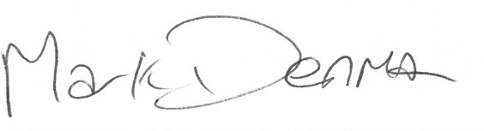
Mark Denman (Managing Director) – April 2024
To be reviewed April 2025

