Company Goal:

The goal of T Denman and Sons is to provide at all times a level of workmanship and service that consistently meets or exceeds the level of customer satisfaction required.

Customer Focus:

The Objective is to satisfy our existing customers and to attract new customers by building and maintaining our reputation in the industry for quality workmanship.

We are committed to respond to the challenges and demands of today's society and focused around the needs and requirements of the customer.

We have structured our organisation and educated our employees to focus on supporting our customers throughout our entire relationship. Both customers and suppliers are seen as partners in a mutually beneficial business venture and we have succeeded in building long-term relationships based on trust.

We will achieve our goal by continuing to develop our expert knowledge and experience, improving and investing in our people, systems, processes, products and facilities.

We are dedicated to training, educating and involving our employees and by reviewing our customer views and perceptions, in the pursuit of enhancing their satisfaction.

Customer Care Standards:

The following expectations are placed on all of our employees and serve to illustrate our commitment to our customers and to continuous improvement.

- Ensuring that all customers receive an efficient and satisfactory service

- Meeting customer needs wherever possible and helping as efficiently and as quickly as possible

- Treating customers with the courtesy, consideration and respect they deserve

- Involving the customer by listening, understanding, considering their views and keeping them informed

- Providing clear and concise information and explanations

- Seeking the customer’s opinions and views to help improve our services.

- Any complaints are recorded, reviewed, responded to quickly and the information used to improve the quality systems

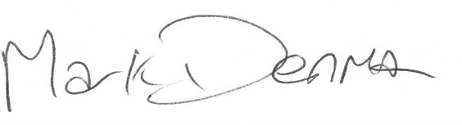
Mark Denman (Managing Director) – Reviewed – April 2024
To be reviewed April 2025

