Denman are committed to treating our customers fairly. We are committed to offering our customers the highest possible standards of service. Our commitment to you, we will;
- Provide you with clear information about the products and service available for your claim.
- Adapt our procedures to suit the individual needs of each customer, taking into account vulnerabilities and special circumstances. Denman will consider all risks associated with your needs and effectively manage these

- Capturing relevant information relating to vulnerability and sharing with all appropriate parties where the necessary consent has been given

- Ascertain your individual needs, preferences and circumstances before we offer/order any product or material.
- Only offer a product/material that we consider suitable for you and always the most suitable from the available options/choices

- Encourage you to ask if there is something you don’t understand

- Behave in a way to encourage you to want a lasting relationship with our company.

- Work with you to allow you to make informed decisions about your claim at any stage of the repair process.

- Deal with you promptly and in a consistent and even-handed manner.

- Incorporate these behaviour’s across everything we do.

- Give you access to a formal complaint’s procedure should you become unhappy with our service or receive what you consider to be detrimental service. Customer Detriment is the loss or damaged experienced by our customers where our service or workmanship does not meet the standards expected or would be considered sub-optimal.
Denman will encourage all personnel and customers to communicate openly about any issues that arise or can be foreseen to promptly resolve these.

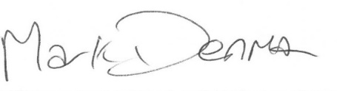
Mark Denman (Managing Director) – Reviewed – April 2024
To be reviewed April 2025

