The Directors and Management of T Denman and Sons fully understand that it is their statutory duty to ensure, so far as is reasonably practicable, the health, safety and welfare of all employees, sub-contractors and any member of the public, who may be affected by Company activities, and undertake to carry out all measures considered reasonably practicable, to promote and maintain a healthy and safe environment when carrying out any operation over which control is exercised, and to organise and maintain a safe system of work enabling all such operations to be carried out with the minimum of risk and of danger.

Safety Plans, Method Statements, Risk Assessments and Permits to Work will be provided whenever dictated by circumstances or if requested by clients or their representatives. The Company will ensure that competent health and safety advice is readily available through their safety advisor and will arrange appropriate inspections, audits and surveys of registered sites to ensure full compliance with statutory requirements and good working practices. The Safety Officer is fully authorised to stop any work, on any site, where he considers undue risk is being taken and serious injury likely. Any work stopped will not continue until reliable confirmation is received that the identified hazards have been removed, eliminated, reduced or are controlled.

The Company will pay due regard to British Standards; Approved Codes of Practice and any Guidance Notes issued on health and safety matters, and ensure that they are implemented at the design, planning, construction and maintenance phases of all contracts where control is exercised.

The undersigned is ultimately responsible for all matters appertaining to health and safety within the Company and will ensure that the contents of the Policy are brought to the attention of all employees, staff, clients and any sub-contractors with a view to implementation and compliance at all times. The Policy may be added to or amended following advice from the Safety Officer or enforcing authorities.

Health and Safety will be kept under constant review and form a permanent item on the agenda of all staff briefings and employee consultation activities relevant accidents; incidents; requests or suggestions for improving the Company’s safety performance, will be discussed with a view to implementation.
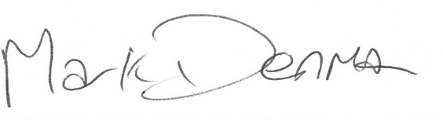
Mark Denman (Managing Director) – April 2024
To be reviewed April 2025

